

German International University

Mechatronics Lab (MCTR704)

Berlin winter 2025

TYPE YOUR PROJECT NAME

Project No. [ x ]

Name: …………………………………… I.D. #:………. Group: ..…..

Table of Contents
Milestone No. / submission date | Content | Page
[1] 08/10/2025 | Project Description …….……………………………….…….……… | 3
[1] 08/10/2025 | Solid works Design: 3D mechanical design views...……...……
[1] 08/10/2025 | Mechanical Components List
[1] 08/10/2025 | DFM report
[1] 08/10/2025 | DFA report
[1] 08/10/2025 | Mechanical Components in 2D with Dimensions…….……………
[1] 08/10/2025 | Pneumatic position step diagram ……………………………….
[2] 22/10/2025 | Electro Pneumatic Circuit…………………………………………….
[2] 22/10/2025 | Electric wiring diagrams (color coded schematic) ………………….
[2] 22/10/2025 | Design the electric control circuit using SOLIDWORKS ELECTRICAL 3D

Project Description

Note
Before starting your project, you must identify the size (dimensions) of the workpiece (object) to ensure that your project design is suitable for the selected object.
Briefly explain your project idea and objectives.
Please note that the project should include a seated frame structure to support and assemble all components. (Refer to the figure below.)

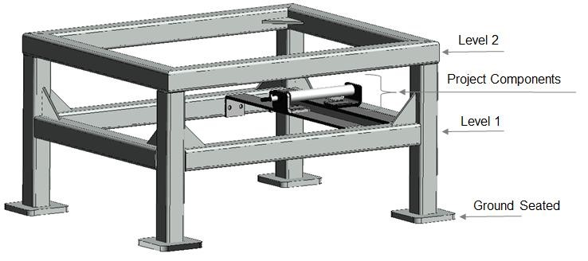

Explain the operation of your project based on your mechanical design and the intended operating process.

Example:

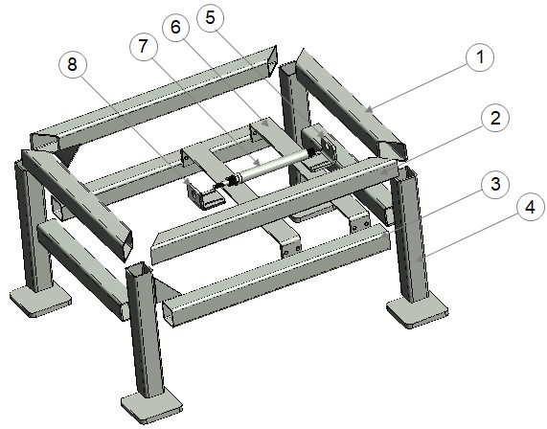

Solid works Design: 3D Schematic Diagram

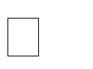 Draw the project in 3D using SolidWorks.
Create an exploded view of the mechanical 3D model and assign a unique number to each mechanical part.
Fill in the table by listing each part number along with its corresponding part name.

Part number | Name
1 | Structure level two – side arm width
2 | Structure level two – side arm length
3 | Structure level one – side arm length
4 | Structure support bar
5 | Cylinder A bracket fixing base side
6 | Cylinder A base support
7 | Cylinder A
8 | Cylinder A bracket fixing piston side

Mechanical Components 2D Projections with Dimensions

Each part in the project is considered a component, including nuts and screws.
Each component should be listed in a separate row in the table provided below.

Fill in the table using the part names and numbers exactly as assigned in the 3D model.
Insert your solid works Drawing in in 2D (with dimensions )

Fill in the table using the part names and numbers exactly as assigned in the 3D model.
Insert your solid works Drawing in in 2D (with dimensions )

Extend the table for your entire components list

Project Components List and Data Sheets Description

• Create a table listing all the components required for your project (both electrical and mechanical).
For each component, include the quantity, a description of its function and purpose, and a representative photo.
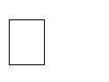 Attach the PDF datasheets of all selected components to the project documentation.

 | Name | Description | Quantity | Photo
1
2
3
4
5
.
.
.
.

x

Pneumatic Step Diagram and Description

- Draw the pneumatic step diagram based on your project’s operation, as shown in the example below.
- Explain your provided pneumatic step diagram; the sequence and the project’s operation. ➢ Below, an Example for the pneumatic step diagram

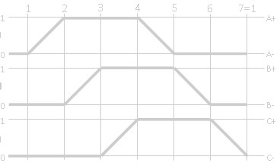

Electro Pneumatic Circuit

- Draw the simulated the pneumatic-electrical circuit using the FluidSim software application (you can download the software from the internet).
- Ensure that the circuit includes all necessary components and operates as a fully functional controller for your project.

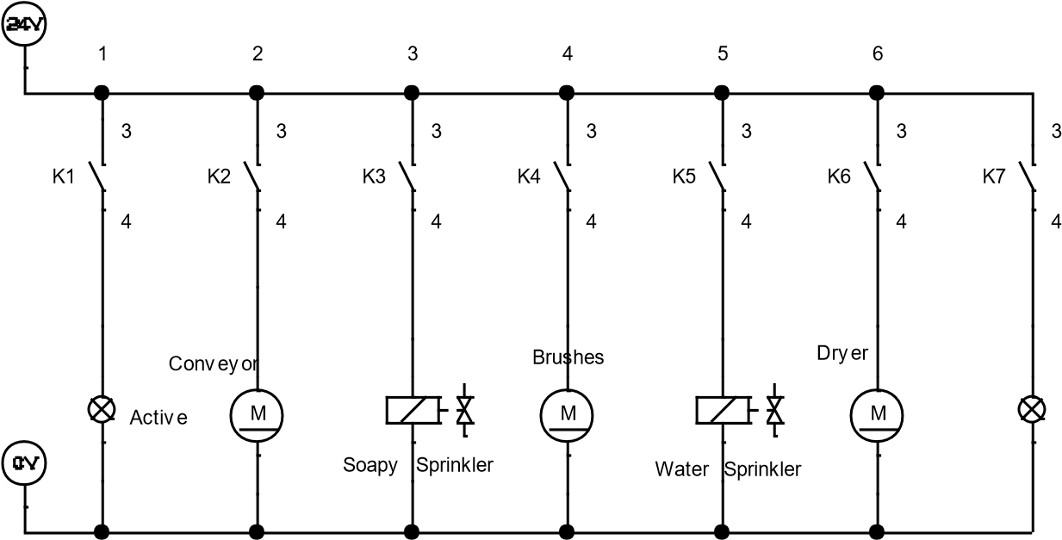

Hardware Model (Electrical + Mechanical)

Controller Operating Panel/ Classic Control Implementation

Part A: Electrical
Step 1: Prepare the list of required materials.
Step 2: Implement the classic control circuit using FluidSim.
Step 3: Design the hardware layout of the classic control system as a front panel with labels. Use the known specifications of each component (power supply, solenoids, relays, I/O terminals, etc.) to determine the appropriate size of the panel for your project.
Step 4: Create the wiring diagram for the components within the control panel.

Part B: Mechanical
Step 1: Prepare the list of required materials.
Step 2: Assemble all components onto the project’s frame structure, including the electrical control panel.

Shown below: An example of a front panel configuration for reference.

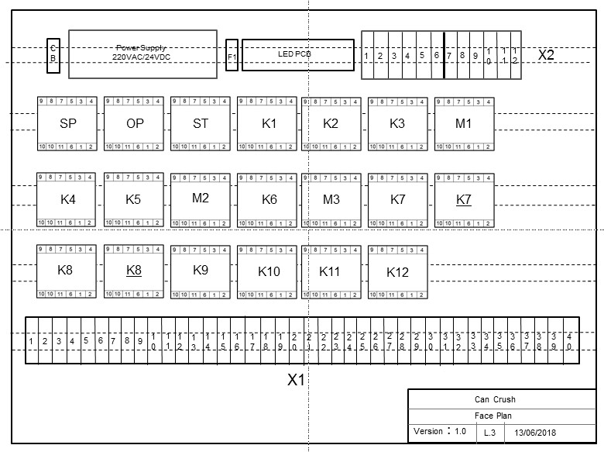

Project Hardware As Built

Insert a picture of your project hard ware implementation

Project Documentation

